Recommended Routes to the University Wisconsin - Green Bay
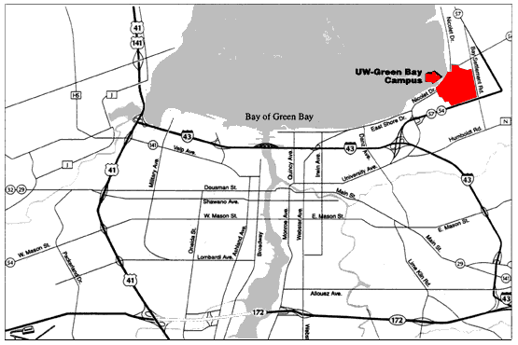
From Austin Straubel Field: Follow Airport Drive (172) east and then I-43 north to Exit 185 (Highway 54-57). Choose the Sturgeon Bay/Algoma exit lane and look immediately for the University Ave./Nicolet Drive exit. Follow Nicolet Drive to campus.
From 41 South of 41-141 North:
Take I-43 south to Exit 185, or take 172 east and then I-43 north to Exit 185. Choose the Sturgeon Bay/Algoma exit lane and look immediately for the University Ave./Nicolet Drive exit. Follow Nicolet Drive to campus.
From I-43 South:
Take Exit 185. Choose the Sturgeon Bay / Algoma exit lane and look immediately for the University Ave./Nicolet Drive exit. Follow Nicolet Drive to campus.
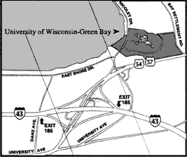
From 29 or 54 West:
Exit at 41, taking 41 north to the I-43 (Tower Drive) exit. Follow I-43 to Exit 185. Choose the Sturgeon Bay/Algoma exit lane and look immediately for the University Ave./Nicolet Drive exit. Follow Nicolet Drive to campus.
The City Routes:
Follow University Ave. (54-57) to the University Ave./Nicolet Drive exit, then Nicolet Drive to campus. Or take Monroe-Quincy or Webster Avenue north from downtown Green Bay to East Shore Drive. Continue east along the bay to the campus.

